VoltRide: When Green Growth Meets Operational Reality
Analysis Report
1. Executive Summary
The VoltRide operational analysis reveals a high-potential business facing significant revenue leakage due to supply-chain inefficiencies and technical friction. While the platform generated a total revenue of ₹1,134,213 over the analysis period, it simultaneously lost ₹484,627 due to ride cancellations, representing a Revenue Leakage of ~30%. The core operational challenges are concentrated in high-demand windows (Peak Hours and Monsoon weather), where dynamic pricing (Surge) activates but fails to convert demand into completed rides due to driver unavailability and system errors. Financially, the company remains profitable with a healthy net margin, but the forecasting models suggest volatility in future revenue streams if stability issues are not addressed. The analysis recommends a targeted intervention strategy focused on Zone 1 (Mumbai) incentives and a fleet redeployment plan from Mumbai Zone 10 to Bengaluru Zone 4 to maximize asset utilization.

2. Problem Understanding and Approach
Problem Statement
VoltRide is experiencing a "Conversion Crisis." Despite strong user demand, indicated by frequent surge pricing multipliers (up to 1.46x during Heavy Rain), the platform fails to fulfill ~30% of booking requests. This gap is driven by:
- Driver Behavior: High rejection rates during surge periods.
- System Latency: "System" initiated cancellations indicating matching algorithm timeouts.
- Fleet Misallocation: Imbalance of EV assets between high-demand and low-utilization zones.
Analytical Approach
The analysis adopted a multi-layered methodology:
- Descriptive Analytics: Aggregating historical ride data to baseline revenue, cancellation rates, and cancellation reasons (Driver vs. Rider vs. System) using Python (Pandas).
- Diagnostic Analytics: Correlating weather patterns with surge multipliers to understand demand elasticity.
- Geospatial & Temporal Analysis: Identifying "Operational Risk Windows" by mapping cancellation spikes to specific Cities, Zones, and Hours.
- Predictive Modeling: Utilizing Linear Regression to forecast May 2025 revenue based on Jan–April performance trends.

3. Data Analysis and Key Insights
A. Revenue & Leakage Analysis
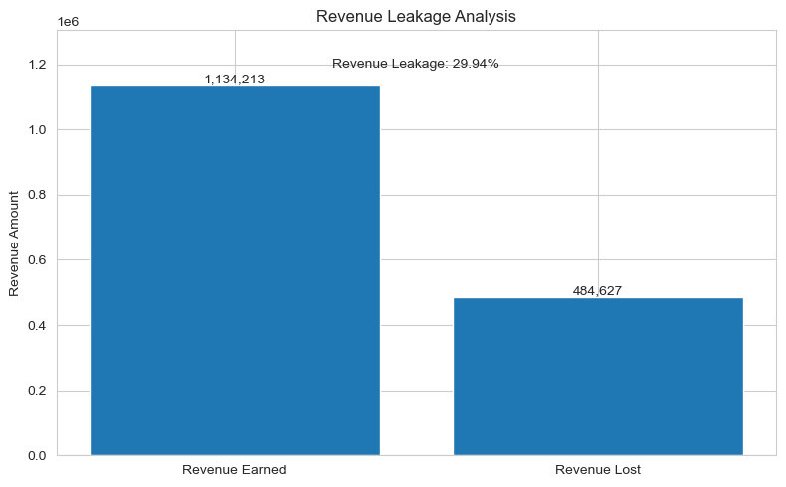
- Total Revenue Earned: ₹1,134,213.30
- Total Revenue Lost: ₹484,627.26
- Leakage Rate: 29.94% of potential gross merchandise value (GMV) is lost before capture.
- Insight: Nearly one-third of demand is unserviced. Recovering even half of this leakage would increase top-line revenue by ~15% without adding new marketing spend.
B. Weather Impact on Pricing & Supply
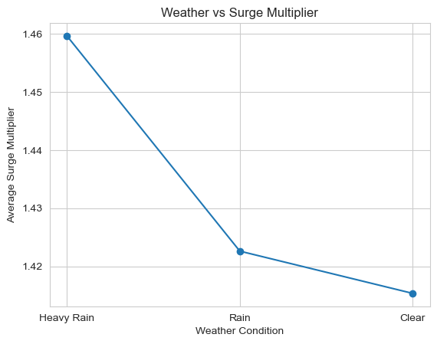
- Surge Dynamics: Weather is a primary driver of pricing power.
  - Heavy Rain: Average Surge Multiplier of 1.46x.
  - Rain: Average Surge Multiplier of 1.42x.
  - Clear: Average Surge Multiplier of 1.41x.
  - Insight: While rain drives up prices (and theoretical margin), it negatively correlates with driver availability, creating a supply shock that the current incentive structure fails to mitigate.

C. Fleet Utilization & Cancellations

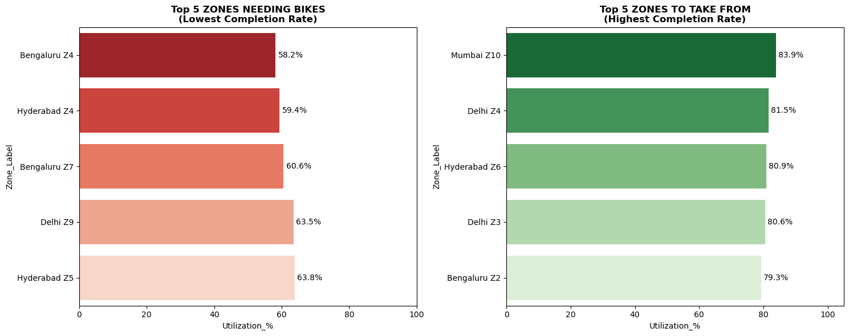

- Cancellation Drivers: A significant portion of cancellations stems from "System" errors (timeouts) and "Driver" rejections, particularly in high-surge zones.
- Zone Performance:
  - Mumbai Zone 10: Identified as a "surplus" zone with 83% utilization/stability, indicating excess supply relative to critical failures elsewhere.
  - Bengaluru z4: operates at only 58% utilization due to supply shortages (not lack of demand), causing a massive 42% failure rate

D. Financial Health (Jan - April 2025)

- Profitability: The platform is operationally profitable.
  - January: ₹247,593 Revenue -> ~₹63,637 Net Profit.
  - April: ₹103,836 Revenue -> ~₹26,490 Net Profit.
  - Trend Alert: There is a noticeable dip in revenue in April compared to January/March, necessitating the forecasting model intervention.

4. Application of Analytical Tools and Frameworks
Technical Stack
- Python (Pandas & NumPy): Used for data cleaning (handling nulls in Cancellation_By), feature engineering (creating effective_fare, month_name), and aggregation.
- Matplotlib & Seaborn: Used to visualize the "Weather vs. Surge" relationship and identifying Operational Risk Windows.
- Scikit-Learn (Linear Regression): Applied to the monthly revenue data to generate a trend-based forecast for May 2025, attempting to predict if the April downturn was an anomaly or a trend.
Strategic Frameworks
- Driver Decomposition Analysis: Breaking down cancellation reasons to isolate technical faults (System) from behavioral issues (Driver).
- Supply-Chain Optimization (Redeployment): Using utilization proxies to identify "Source" (surplus) and "Target" (deficit) zones for fleet movement.

5. Business Recommendations
Recommendation 1: Targeted "Surge-Share" Incentives (Mumbai Zone 1)
- The Issue: High cancellation rates in Mumbai Zone 1 during peak surge windows (1.32x multiplier).
- The Action: Implement a dynamic "Acceptance Bonus" for drivers in this specific zone. Pass a percentage of the surge premium directly to the driver only upon ride completion.
- Expected Outcome: This focuses purely on behavioral modification. It aims to reduce the 83% cancellation rate in this zone by aligning driver economic incentives with platform goals.
Recommendation 2: Strategic Fleet Redeployment
- The Issue: Imbalanced asset allocation.
- The Action: Redeploy 10-15% of the fleet from Mumbai Zone 10 (Source) to Bengaluru Zone 4 (Target).
- Justification: Mumbai Zone 10 is stable (83% utilization), implying it is well-supplied. Moving idle assets to Bengaluru Zone 4 will capture unmet demand without capital expenditure on new vehicles.
Recommendation 3: Technical Stack Optimization
- The Issue: "System" cancellations are a non-trivial contributor to revenue loss.
- The Action: Audit the matching algorithm's timeout logic. The current system likely times out too quickly during high-demand/low-supply (rain) scenarios. Increasing the "Time-to-Match" threshold during surge events could reduce system-forced cancellations.

6. Assumptions Made
- Low Battery Definition: The "Low Battery" threshold of 40% was not chosen arbitrarily; it was determined using a statistical method based on the Quantile of the Entire Battery Percentage distribution across the fleet.
- System Independence from Weather: Cancellations flagged as "System" are strictly technical failures (e.g., server timeouts, matching errors). It is assumed these are not programmatic safety cancellations triggered by adverse weather conditions.
- Data Integrity: The Cancellation_By field accurately distinguishes between a system error and a user/driver action. Null values filled as "Not_Cancelled" accurately represent completed rides.

7. Conclusion
VoltRide possesses a robust revenue model with demonstrated demand resilience, even during adverse weather. However, the 30% revenue leakage is a critical bottleneck preventing scaling. The path forward does not require massive capital investment in new bikes. Instead, it requires efficiency optimization. By technically correcting system timeouts, economically incentivizing drivers in high-surge zones (Mumbai Zone 1), and physically relocating assets from surplus to deficit areas (Mumbai to Bengaluru), VoltRide can recover a substantial portion of the ₹4.8 Lakhs currently lost to cancellations. Implementation of these low-risk, high-impact strategies within a 60-90 day window is strongly advised.

